Assignment -3

Bucket And Watson assistant

|  |  |
| --- | --- |
| Student Name | B.FARHANA |
| Student Roll Number | 960219104042 |

Questions:

1.Create a Bucket in IBM object storage.

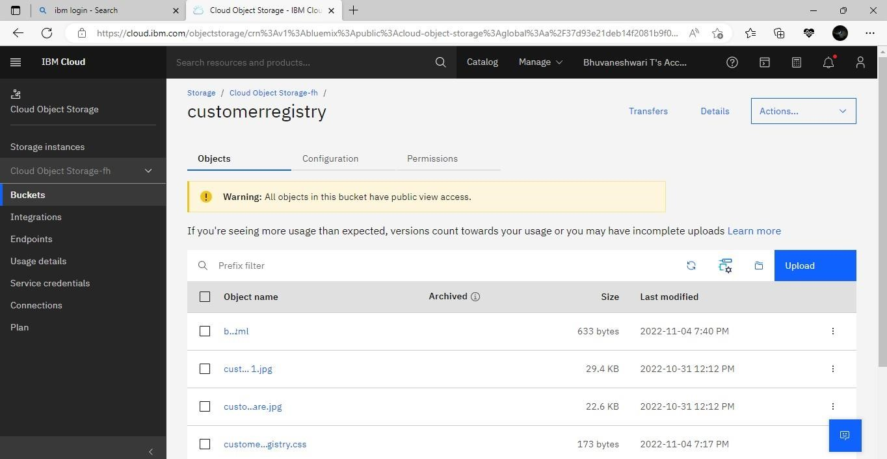

2.Upload an 5 images to ibm object storage and make it public. write html code to displaying all the 5 images.

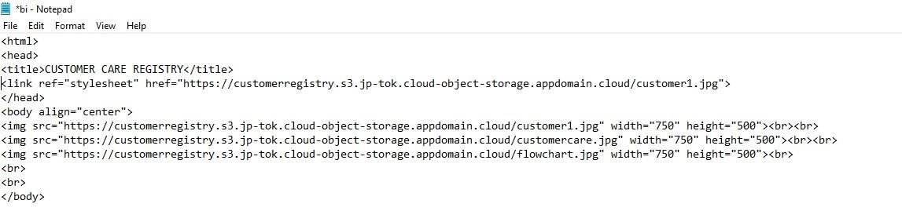

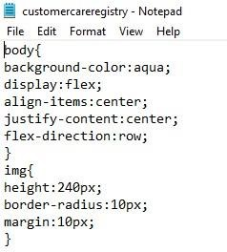

3.Upload a css page to the object storage and use the same page in your HTML code.

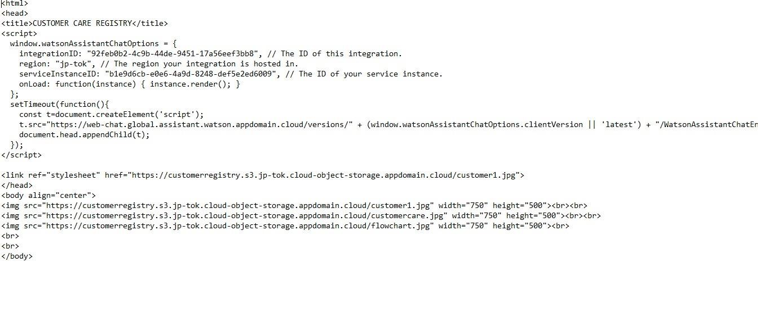

Output:-

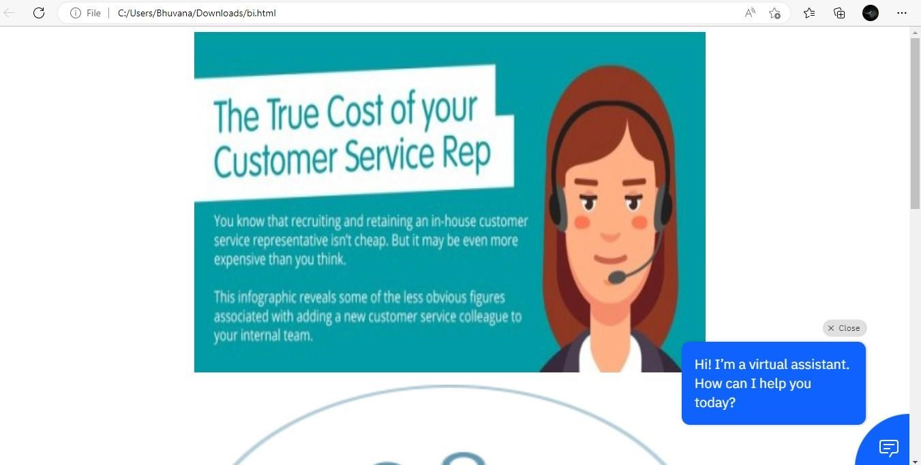

4.Design a chatbot using IBM Watson assistant for hospital. Ex: User comes with query to know the branches for that hospital in your city. Submit the web URL of that chat bot as a assignment.

Url :[- chatbot link](https://web-chat.global.assistant.watson.appdomain.cloud/preview.html?backgroundImageURL=https%3A%2F%2Feu-gb.assistant.watson.cloud.ibm.com%2Fpublic%2Fimages%2Fupx-2187bdc6-3463-4336-a0e5-105ac4d979db%3A%3A31897cd3-e620-4527-80d8-c93d7c618899&integrationID=fd3649a9-27f7-43a9-96c0-5ca4d5bbf885&region=eu-gb&serviceInstanceID=2187bdc6-3463-4336-a0e5-105ac4d979db) <- click

Image-

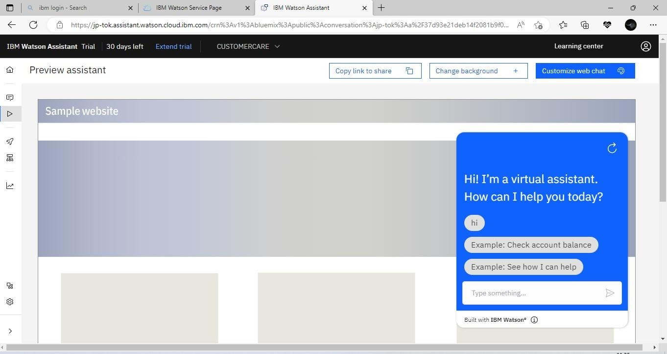

5 .Create Watson assistant service with 10 steps and use 3 conditions in it. Load that script in HTML page

